

**MATHEMATICS  
METHODS**

**Test 2 – Equations, Polynomials, Functions and Graphs**

**Chapters 1 and 4**

**Semester 1 2015**

# 

**Section Two - Calculator Assumed**

Time allowed for this section

Working time for this section: 45 minutes

Marks available: 40 marks

## Material required/recommended for this section

##### To be provided by the supervisor

This Question/Answer booklet

Formula sheet

##### To be provided by the candidate

Standard items: pens, pencils, pencil sharpener, eraser, correction fluid, ruler, highlighters

Special items: drawing instruments, templates, notes on one unfolded sheet of A4 paper, and up to three calculators satisfying the conditions set by the Curriculum Council for this course.

## Important note to candidates

No other items may be used in this section of the examination. It is **your** responsibility to ensure that you do not have any unauthorised notes or other items of a non-personal nature in the examination room. If you have any unauthorised material with you, hand it to the supervisor **before** reading any further.

**Multiple choice questions – select the best response**

1. Find the domain and range of .

A Domain {x: all real x}, range {y: all real y}

B Domain {x: all real x ≥ 2}, range {y: all real y ≥ 0}

C Domain {x: all real x ≠ 2}, range {y: all real y ≥ 0}

D Domain {x: all real x ≤ 2}, range {y: all real y ≥ 0}

E Domain {x: all real x ≥ 2}, range {y: all real y ≤ 0}

1. Determine the solutions of p(x) = 2x3 + 9x2 − 5x

A  − 5, 0,  B , 0, 5

C   0, 1, 5 D   0, 2, 5

E  −5, 0, 2

1. Factorise x3 + 6x2 + 5x – 12.

A (x – 1)(x – 3)(x + 4) B (x – 1)(x + 3)(x + 4)

C (x – 1)(x – 3)(x – 4) D (x + 1)(x – 3)(x + 4)

E (x + 1)(x + 3)(x – 4)

1. Solve the equation 2*x*2 + 7*x* − 3 = 0, for *x* correct to 2 decimal places.

A *x* = −3.89 and 0.39 B  *x* = −0.5 and −3

C  *x* = −0.77 and −7.72 D  *x* = 0.39 and 3.89

E  *x* = 0.77 and 7.72

1. Solve the equations 8*a* + *b* = −12 and 4*a* − 3*b* = −20 simultaneously.

A  *a* = 2, *b* = −28 B *a* = −3.5, *b* = 16

C  D *a* = 2, *b* = −28

E  *a* = −2, *b* = 4

**Short Answer Questions**

1. (2 marks)  
   Solve 3x2 – 5x – 12 = 0
2. (2 marks)  
   For the function P(x) = 2x3 + 4x2 – x + 1, find the remainder when P(x) ÷ (x – 4)
3. (3 marks)  
   The amount of fuel used by a car is directly proportional to the distance travelled. On a trip of 810 km, a family car used 60 litres of fuel. How far could the car travel on 76 litres of fuel?
4. (6 marks)  
   For the given points A(−2, 3) and B(−1, −4):
5. find the midpoint M of A and B

1. find the distance between A and B
2. find the gradient of line AB
3. (4 marks)  
   State domain and range of the following functions:
   1. 
   2. 

1. (4 marks)  
   Graph 

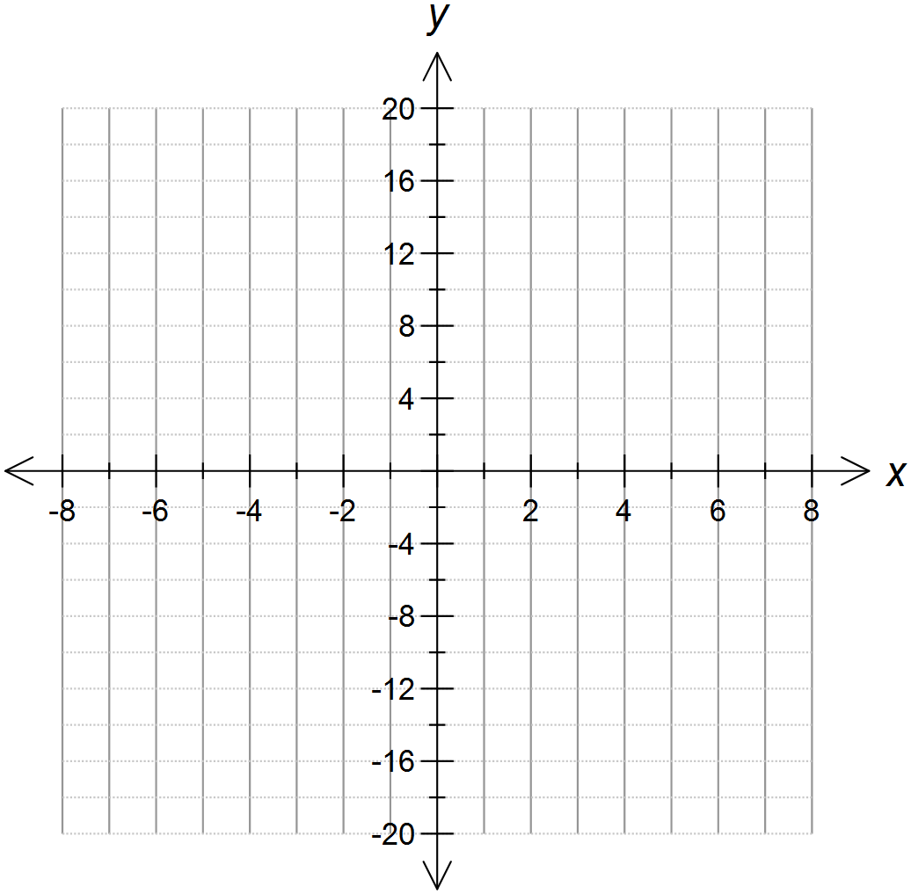

1. (14 marks)  
   A Wilderness Trekking tour operator offers complete packages to the Tasmanian World Heritage areas from Launceston. The cycling tours may be from 3 to 12 days in length. They cost $780 for the 3-day tour and $180 for each additional day.
2. Draw a graph showing the cost of the cycling tours. [4]



b. Find a relationship between the number of days and the cost of the tours. [2]

The operator also offers walking treks of any duration from 1 to 20 days with a flat rate of $210 per day.

c. Draw a graph of the cost of the walking treks. [4]



d. Find a relationship between the number of days and the cost of the treks. [2]

e. State the circumstances under which each of the walking or cycling options would be cheaper. [2]

**End of Test**